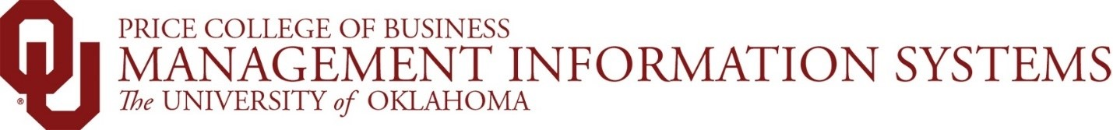 

**MIS 3213  
Business Data Analysis  
Fall 2024**

**Overview**

This class is a project-based class that requires students to analyze an organization’s selected data to address the areas of interest or concern identified by the organization.  The project is intended to represent a real-world situation where students must utilize their individual skills and learn how to combine those skills with those of their teammates.  These skills will include those learned and polished in IT related coursework, but also analytical, interpersonal, problem-solving, team building, and project management skills necessary to become a contributing member of an efficient and effective team.  Upon completion of the project, students will present their methodology, findings, and recommendations for the organization to fellow University of Oklahoma students and faculty, as well as industry professionals.

**Organization**

The organization chosen for this project is Love’s Travel Stops.  Love’s Travel Stops is the nation’s leading travel stop network with 644 Love’s locations in 42 states.  The data submitted by Love’s comprises of 20,000 professional drivers (i.e. truck drivers) and 3 years of driver sales aggregates (fuel sales/gallons, merchandise sales), monthly campaign data going back to January 2022, and three years of monthly department sales (August 2021 – July 2024).

**Data**   
Love’s has provided five datasets that will be used in this analysis.  These datasets are as follow:   
 1.  Driver Lookup

2.  Driver 3 Year Aggregates

3.  Driver Monthly Campaign

4.  Driver Monthly Product Sales

5.  Store Lookup

Please refer to the data dictionary for a more detailed description of each dataset.

**Project Objectives:**

Analyze customer data, focusing on 3-year driver sales aggregates, monthly product sales, and campaign data.

**Your analysis should address the following questions:**

* Which campaign(s) deliver the most net-benefit to Love’s, through incremental fuel gallons, fuel visits and merch sales?
* Is the merchandise campaign more or less effective for certain products? Would you recommend any changes to the structure of the promotion?
* How do join and achieve rates vary by segment? What drives this behavior?
* How do a customer’s total sales and monthly product sales contribute to understanding individual customers, and what insights can be gained for each segment group?

**Additional questions to consider:**

* Which campaign send channel (email, push, SMS) have the greatest impact on customer campaign joins and achievements, and how does the effectiveness of these channels differ across various segment groups?
* How can analyzing historical campaign data help develop a more effective strategy to boost customer sales?
* Do different segment groups tend to visit stores in varying divisions, states, etc.?
* Does the driver’s age influence the number of gallons they fuel in a month?

**Deliverables**

Each team is responsible for producing the following in order to satisfy the requirements of this project:

1. Project updates/checkpoints throughout the project, at designated intervals.  These updates are intended to help ensure the project is progressing and that all team members are participating in the project.
2. A written document that will be submitted on Canvas that outlines the methodology, findings, and recommendations for this project.  The document is not limited to these three items and can include any and all information considered to be relevant to this project.
3. A PowerPoint presentation that will be submitted on Canvas that will also be presented to fellow University of Oklahoma students and faculty, as well as industry professionals on Saturday, December 7th, 2024.
4. A live presentation of the PowerPoint presentation noted in 3. above.  All team members must participate in this participation.
5. There are three sections of this class in the Fall 2024 semester, and together there are roughly 20 project teams.  All teams are working with the same datasets, and all teams will present their findings.  The team that demonstrates the best in-depth analysis, findings, recommendations, presentation, and professionalism will be considered the winner of this competition.  Lunch with CMISS members for the winning team, runner-up, and instructors will be provided.